**Architectural overview cum Solution Roadmap of the idea proposed:-**

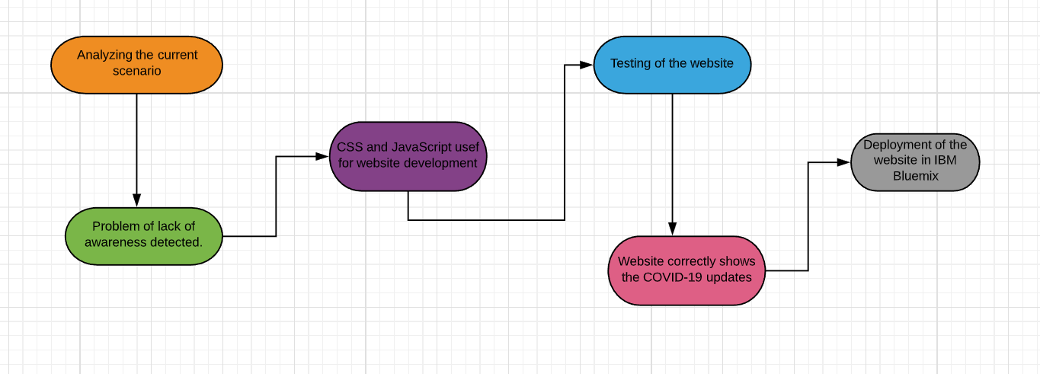

**Future improvisations and implementations of the project:-**

The reason why this project is unique in its own way is because it is absolutely simple to deploy, navigate and user friendly. But still it has got quite scope of further improvement like featuring a real-time database to address different problems demographically, ensuring that the website can be deployed even more widely.

Stating the above mentioned reasons, funding requirements are a must, if the website has to be deployed in a commercial scale across a wide range of platforms, as well as for the constant maintenance and enhancement of the website with the changing technology of the hour

**Business model:-**

Keeping in mind the funding requirements of the project to be deployed commercially as well as adhering to the objective of the project to address a social cause, we propose to follow the advertising-based business model for this project. Since our prime objective is to create awareness amongst the masses regarding COVID-19, we feel that advertising will fulfil our project objective to a great extent. In this manner, we hope to serve the society keeping in mind the “need of the hour rule”-social distancing as well as promoting the project on a commercial scale.

**Sustainability plan:-**

Since, the project is aimed for a social cause, we believe that its benefits should be harvested by everyone in the society across visual and physical impairments. Keeping this prime objective in mind, in order to ensure the sustainability of the project, the following steps will be taken in the future:-

* The prime risk that any website faces in today’s technological world is the risk of security breaches. So, in order to protect our website from malware attack, we will ensure that any latest version of our website is available with the latest antivirus software before deploying it commercially.
* In order to reach out to the visually and physically handicapped, we intend to adopt new measures like providing more keyboard shortcuts, using contrasting enlarged text to design the website, etc.
* For the illiterate, measures will be taken to make the website as picturesque as possible so that information can be conveyed in a simple manner to our users.

**Deploying the website – creating API**



 